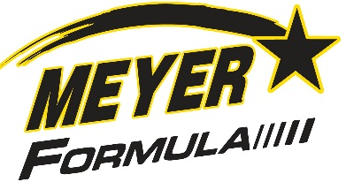 Meyer Truck Mount 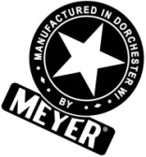
Formula Vertical TMR Mixer
815 – 1,315 Cubic Foot Capacity Available for Truck Mount Application

*HD Self-Compensating Hydrostatic Drive on F815 / F1015 / F1215
Single Drive on Standard Versions / Dual Drive on “Plus” & “Commercial” Units
All Feature the Exclusive Meyer Auger Timing System for the most precise ration!

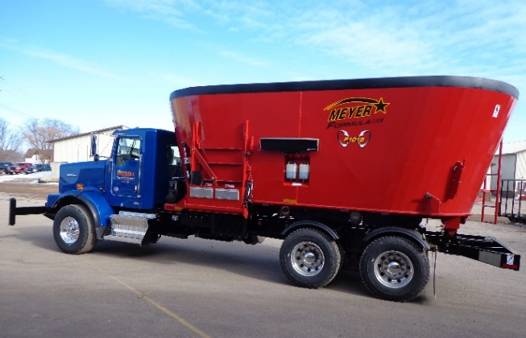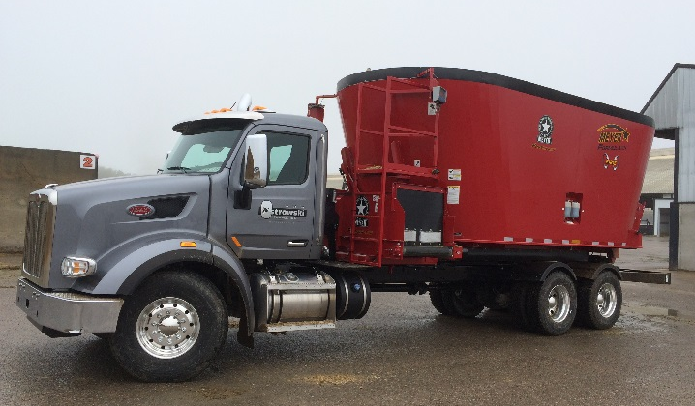
F1015 LH Side Door w/Slide Tray F1215 Front Door/Flat Belt Conv.
Meyer Formula – A Step Ahead of the Rest!
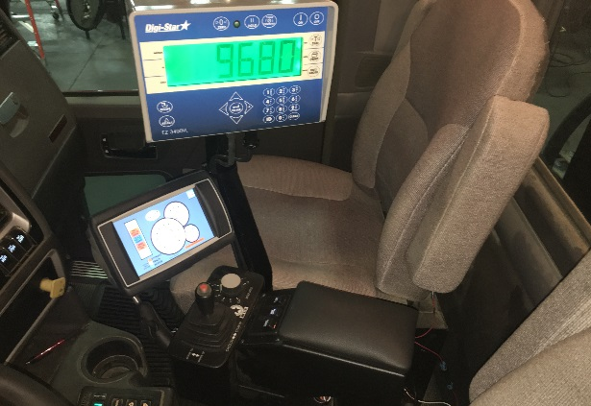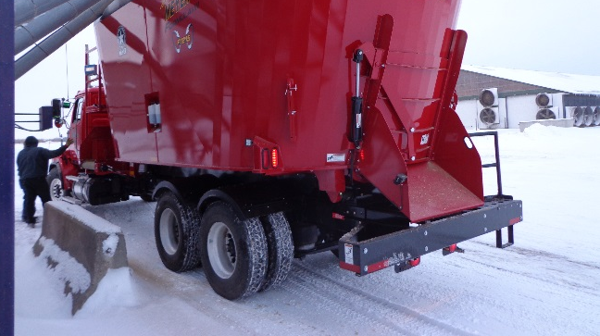
Deluxe In-Cab Touch Screen Display Rear Commodity Door, Integrated back-up
Joystick Control & Variable Speed Dial Camera & Bunk Light Pkg - Optional
Mixer Load Heights:
Must Add the Distance from the Ground to the Top of the Truck Frame Rails to these Measurements
Mixer Model | Base Machine (no extension) | With Belt Capacity Extensions
F815 | 77” | 83”
F1015 | 90” | 96”
F1215 | 102” | 109”
See a Meyer Formula Product Brochure for Specifications
Phone# 1-800-325-9103 meyermfg.com contact us: sales@meyermfg.com

