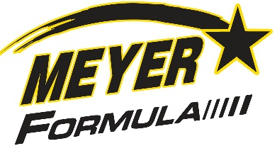 New F510 PRO 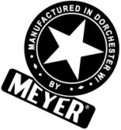
Meyer Formula Vertical TMR Mixer
Model F510 PRO - offering 510-570 Cubic Foot Capacity

Formula Premium Single Screw Vertical Mixer
Same extensive line of conveyor options as the popular twin screw models
Front Door & Side Door Versions offering our popular belt conveyor systems to eliminate carryback & noise while maximizing feed delivery performance!
NEW!
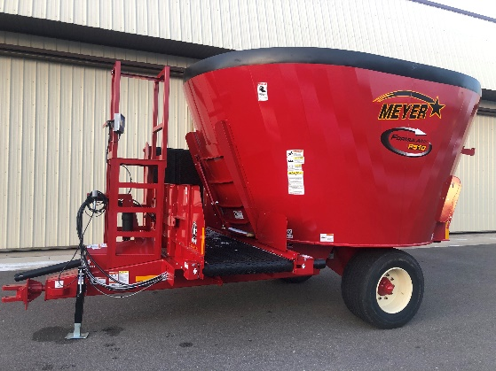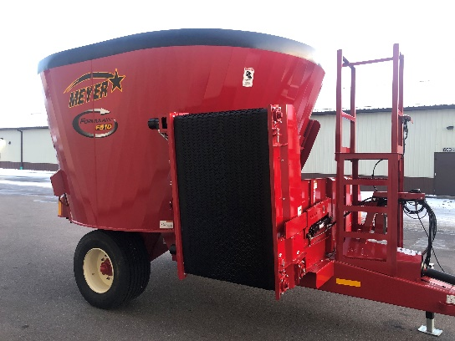
Front Door or Side Door - F510 PRO Our popular belt incline conveyor
Belt or Chain Conveyors Available Unloads off Either the Incline or Flat Side
Viewing Platform Optional on Front Door Models Belt Capacity Ext (pictured) or Hay Retention avail

Meyer F510 PRO-Upgraded to meet the needs of your livestock operation

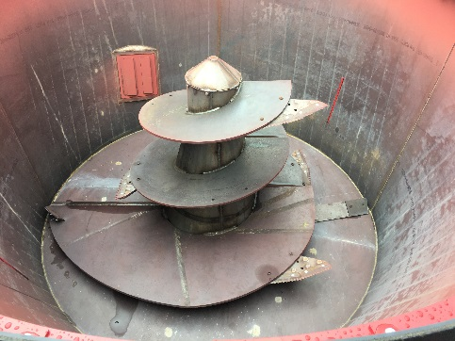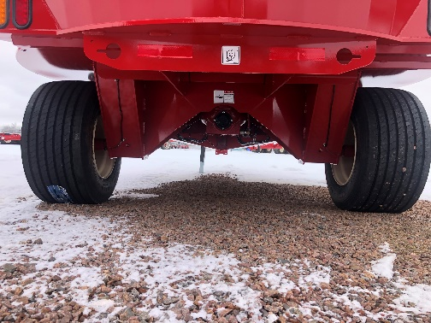
40 Max RPM Auger Speed for Fast Cleanout The PRO Series – HD Frame/Axle
Magnet options: kicker arm, tank, deflector & more Premium Floatation & Ride
Unique, Sectional knife system / auger kicker arm with Uncompromised Strength

STANDARD FEATURES OF THE F510 PRO:
1000 RPM Direct Drive, Shear-Bolt Protection, Upgraded - HD VM10 Planetary Drive System
Cone Center Augers w/Adj Lead Edge Scraper / High Clearance Design Ideal in Rough Terrain
Robust undercarriage w/3 point scale & large diameter tires - Full Line of Scale Head Options

Phone# 1-800-325-9103 meyermfg.com contact us: sales@meyermfg.com

